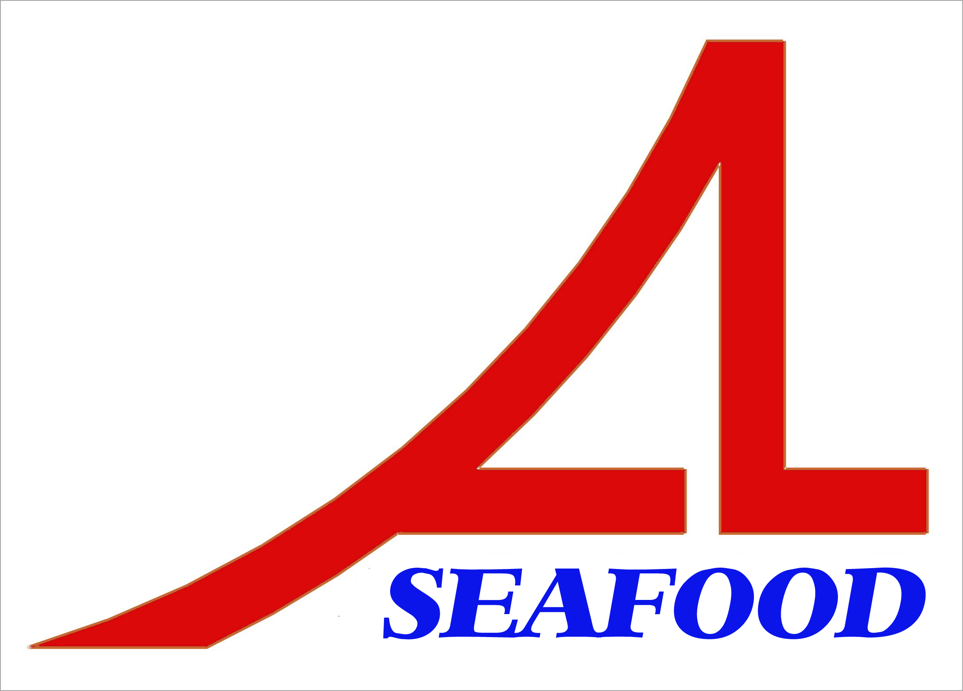AN LAC SEAFOOD CO., LTD.

Lot A14, 4A Street, Hai Son Industrial Zone, Duc Hoa District, Long An Province, Vietnam.
* E-mail: longan@anlacseafoods.com * Website: www.anlacseafoods.com

* Tel : 84-72-3850606 * Fax : 84-72-3850608

OFFER SHEET

Date: Nov. 24, 2017

To: KOJUBU B&F CO., LTD. - CHUNGJU BRANCH
77, Sinseok 3-gil, Sinni-myeon, Chungju-si, Chungcheongbuk-do, Korea

TEL : 82-31- 554-6500

We would like to offer you the products by our company with terms and conditions as follows:

1/ GOODS:

No. | DESCRIPTION OF GOODS | SIZE | QUANTITY  (KGS) | CFR INCHON PORT, KOREA  (USD)
 |  |  |  | UNIT PRICE | Amount
1 | DRIED SEASONED LEATHER JACKET | 14 x 30 | 3,000.00 | 9.80 | 29,400
2 | DRIED SEASONED LEATHER JACKET | 2L | 3,000.00 | 9.80 | 29,400
3 | DRIED SEASONED LEATHER JACKET | M | 6,000.00 | 9.80 | 58,800
TOTAL |  |  | 12,000.00 |  | 117,600

Say : US DOLLAR ONE HUNDRED SEVENTEEN THOUSAND SIX HUNDRED ONLY. (CFR INCHON PORT, KOREA)

Quantity: +10% is acceptable.

2/ SHIPMENTS : 30 days after receiving L/C at sight
3/ PAYMENT :
By irrevocable L/C at sight into account of the seller’s No.: 101000268614 at VIETNAM PUBLIC JOINT STOCK COMMERCIAL BANK – GIA DINH BRANCH
Address: 495 - 497an Duong Vuong Street, Ward 08, District 05, Hochiminh City, Vietnam.
Swift. WBVNVNVX

BENEFICARY: AN LAC SEAFOOD CO., LTD.

Valid: Dec. 09, 2017

Looking from and to your early reply.

Thanks and best regards

AN LAC SEAFOOD CO., LTD
DIRECTOR

